1

Assignment 1.3 – Environment Setup

Eric McCool
Bellevue University - School of Science and Technology
Web201-339A Internet Systems Architecture
Professor Kumar
October 19, 2022

2
Assignment HTML validator:
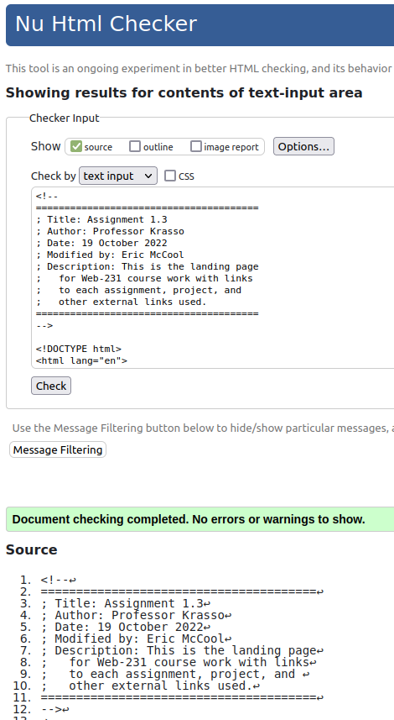

The one-hit wonder.

3
Assignment CSS validator:
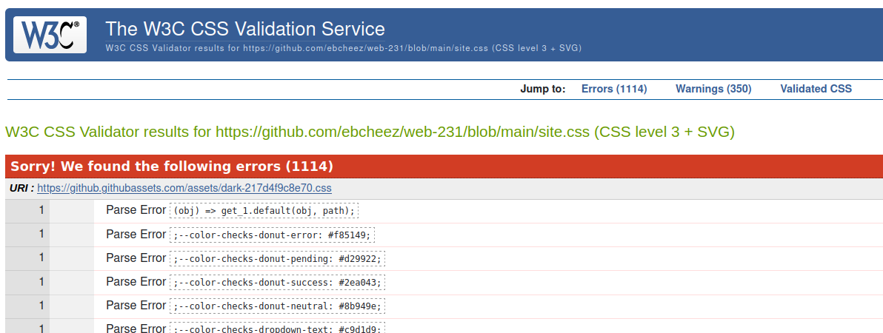
The page looks correct, yet I get 1,114 errors in the css validator. I have tried:
- https://github.com/ebcheez/web-231/blob/main/index.html <= this gives the above error
- https://github.com/ebcheez/web-231/index.html <= this one gives the below error
- https://github.com/ebcheez/web-231/blob/main/site.css <= this gives the above error
- https://github.com/ebcheez/web-231/site.css <= this one gives the below error
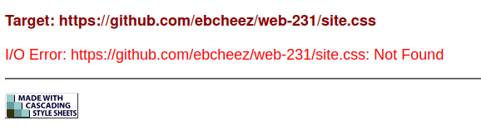
I am curious. What does the “/blob/main/” represent? Every file shows this in the search bar. Directories show a /tree/main/ added to the path in the search bar in place of the /blob/main/. Eric
4
Assignment CSS Validator:
I was trying to use the “By URI” tab. I noticed the “By direct input” tab.
